Using a radio group to filter by image orientation

This is the second part of a series of 3 to be followed in order.

Take a backup of your images application (from the Application page choose Import/Export and then export)

Edit Page 2 of your images application – this is easier in Component View

Create a new Item

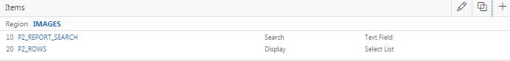

Choose Radio Group as the Item Type

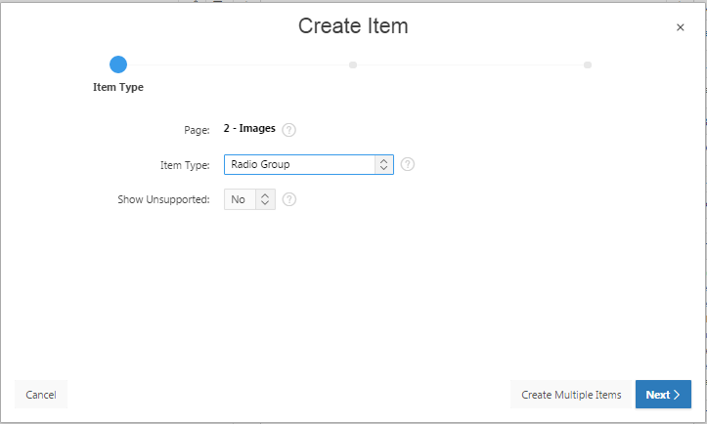

Name the item P2_ORIENTATION and put it in the IMAGES region. 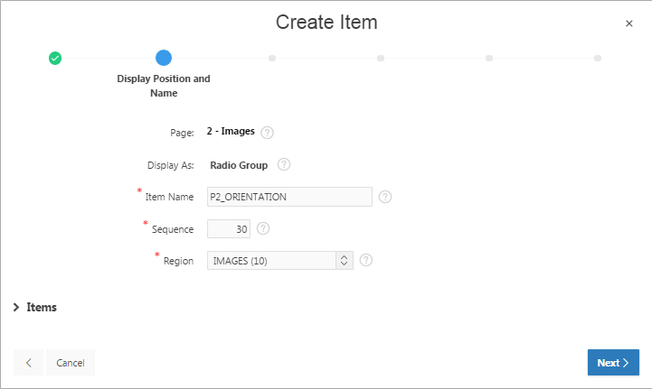

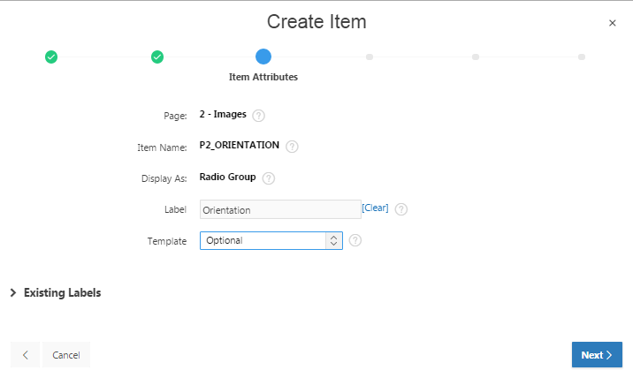

Click Next and set the values below

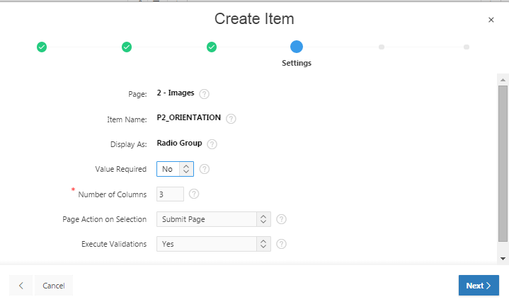

Create a static list of values to associate with the Radio Group

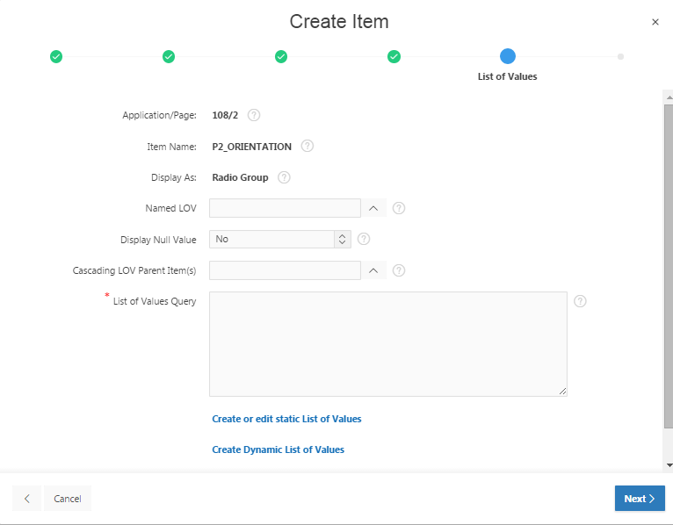

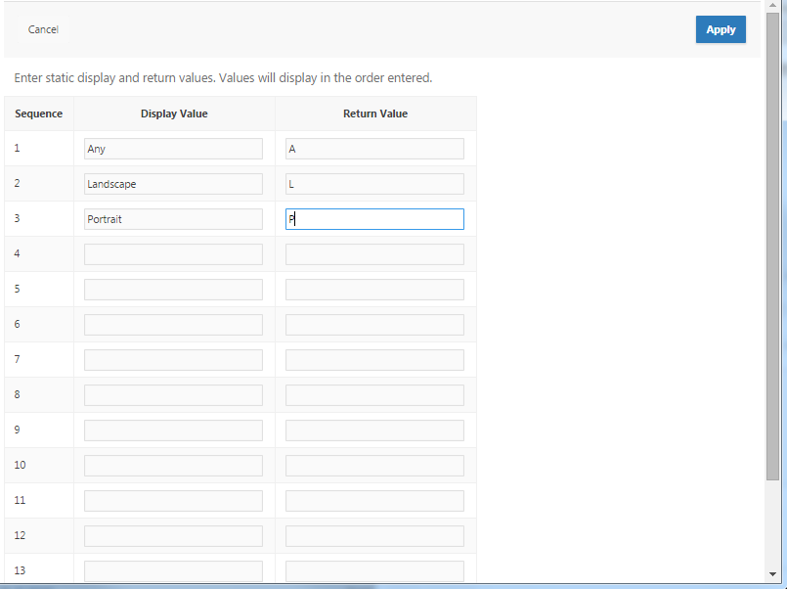

resulting in

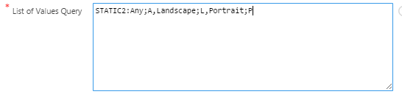

Set the default to A and create the item.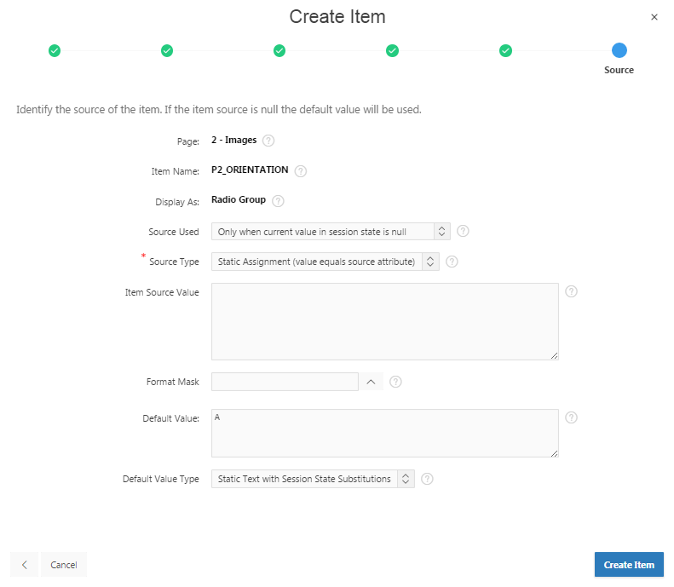

Now Run the application showing the Radio Group defaulting to Any

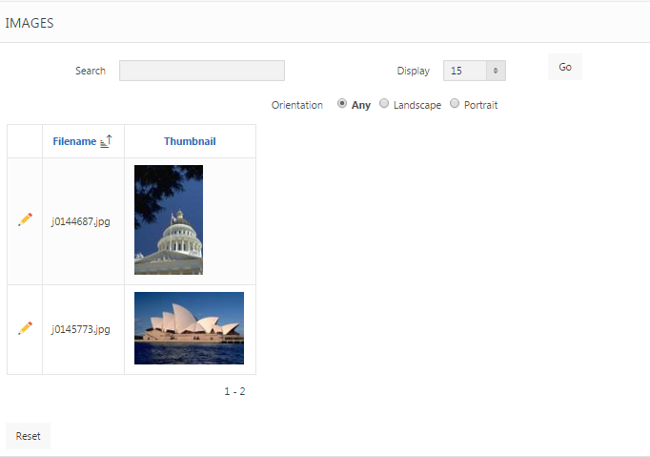

Now to incorporate the radio group into the report query.

This is the current query.

select

"IMAGE_ID",

"FILENAME",

dbms_lob.getlength("THUMBNAIL") "THUMBNAIL"

from "IMAGES"

where

(

instr(upper("FILENAME"),upper(nvl(:P2_REPORT_SEARCH,"FILENAME"))) > 0

)

Change the type to SQL Query (PL/SQL function body returning SQL query) or Classic Report (based on Function) and wrap the query in a PL/SQL block by editing the Region Source to

DECLARE

l_query VARCHAR2 (500);

BEGIN

l_query := '

select

"IMAGE_ID",

"FILENAME",

dbms_lob.getlength("THUMBNAIL") "THUMBNAIL"

from "IMAGES"

where

(

instr(upper("FILENAME"),upper(nvl(:P2_REPORT_SEARCH,"FILENAME"))) > 0

)

';

RETURN l_query;

END;

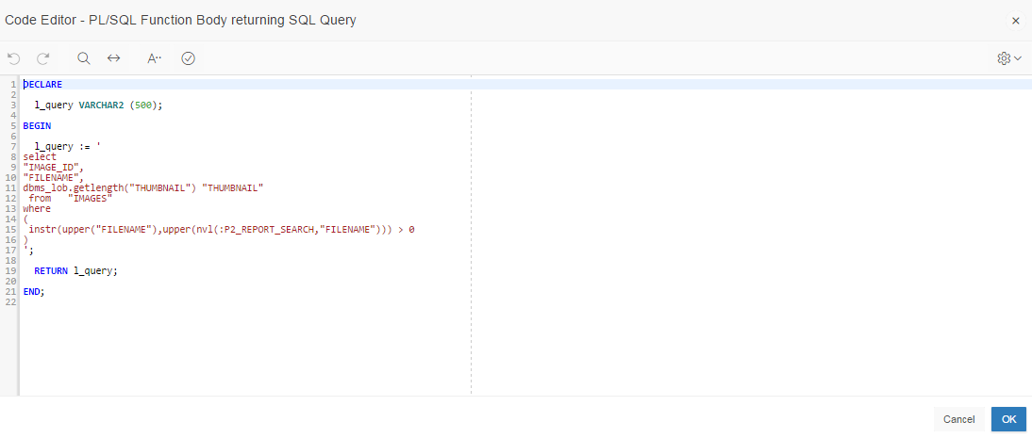

Apply changes and run the page – you will probably lose the thumbnail and the link to Page 3. To rectify this, reset the properties of the THUMBNAIL column

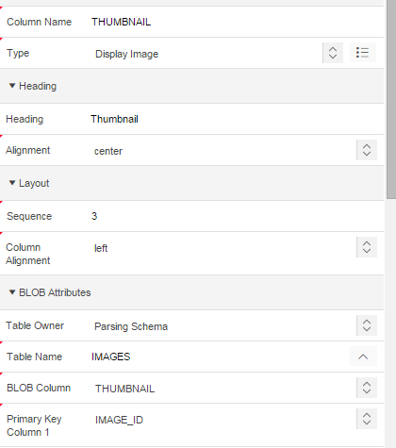

And re-establish the link by editing the properties of the IMAGE_ID column

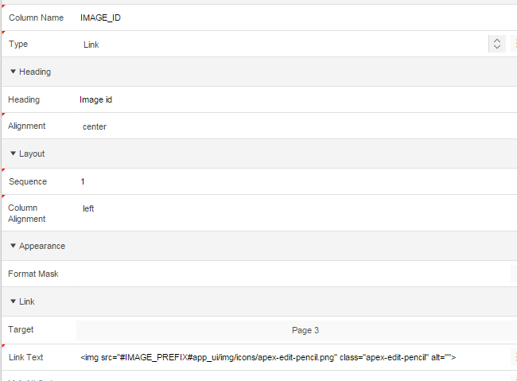

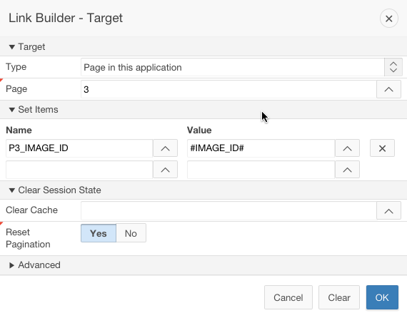

Now you’ll need to modify your code to add the orientation logic.

DECLARE

l_query VARCHAR2 (500);

l_orientation CHAR (1) := v('P2_ORIENTATION'); -- from radio group

BEGIN

-- the table alias is important in order to call the methods

l_query := '

select

"IMAGE_ID",

"FILENAME",

dbms_lob.getlength("THUMBNAIL") "THUMBNAIL"

from "IMAGES" i

where

(

instr(upper("FILENAME"),upper(nvl(:P2_REPORT_SEARCH, "FILENAME"))) > 0

)

';

IF l_orientation <> 'A' THEN

IF l_orientation = 'L' THEN

l_query :=

l_query||' AND i.image.getWidth() > i.image.getHeight()';

ELSIF l_orientation = 'P' THEN

l_query :=

l_query||' AND i.image.getWidth() < i.image.getHeight()';

END IF;

END IF;

RETURN l_query;

END;

Now run your page - if all has gone well you should be able to filter by orientation by selecting from the radio group

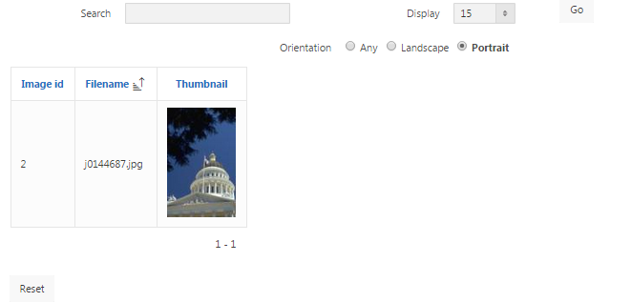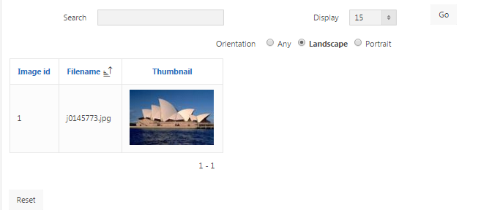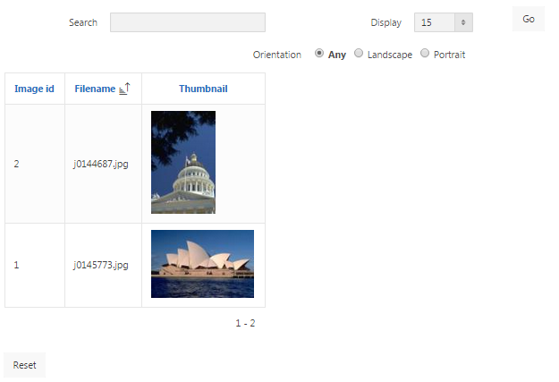

You can test your PL/SQL code in SQL Developer by changing the colon prefixing any item name to an ampersand creating a substitution variable, e.g. &P1_ORIENTATION, and using DBMS_OUTPUT.PUT_LINE instead of RETURN, e.g. DBMS_OUTPUT.PUT_LINE(l_query). Switch on DBMS OUTPUT on too.